Uniform Repeated Components

Definition
# Source: AI Source: Provided by: [Data Path: Persons Table -> ID Column: 1, Name_En Column: Motasem Essam] -> From: [ChatGPT] on [7/25/2026]
Uniform repeated components are composite-solid components formed by repeating the same geometric shape according to a consistent dimensional pattern.
The repeated components may have identical dimensions or follow a uniform dimensional rule, such as a constant size, a fixed scale factor, or a regular dimensional progression.
They are generally distributed in an organized arrangement, with consistency in their dimensions, spacing, orientation, or repetition pattern.
Examples include:
- Identical cubes arranged in a regular grid.
- Cylinders repeated with equal radii and heights.
- Cubes whose side lengths increase by a constant amount.
- Rectangular prisms repeated according to a fixed dimensional ratio.
Important distinction: Uniform repetition does not always mean that every component has identical dimensions. It means that the repetition follows a consistent rule. If all components have exactly equal dimensions, the arrangement is also an identical-component arrangement.

Simple Definition
# Source: AI Source: Provided by: [Data Path: Persons Table -> ID Column: 1, Name_En Column: Motasem Essam] -> From: [ChatGPT] on [7/25/2026]
A composite solid made by repeating components according to a consistent size or dimensional pattern.
For example, a structure made from cubes with side lengths of 2 cm, 4 cm, and 6 cm follows a uniform dimensional progression because each successive cube increases in side length by 2 cm.

Geometric Representation
# Source: AI Source: Provided by: [Data Path: Persons Table -> ID Column: 1, Name_En Column: Motasem Essam] -> From: [ChatGPT] on [7/25/2026]
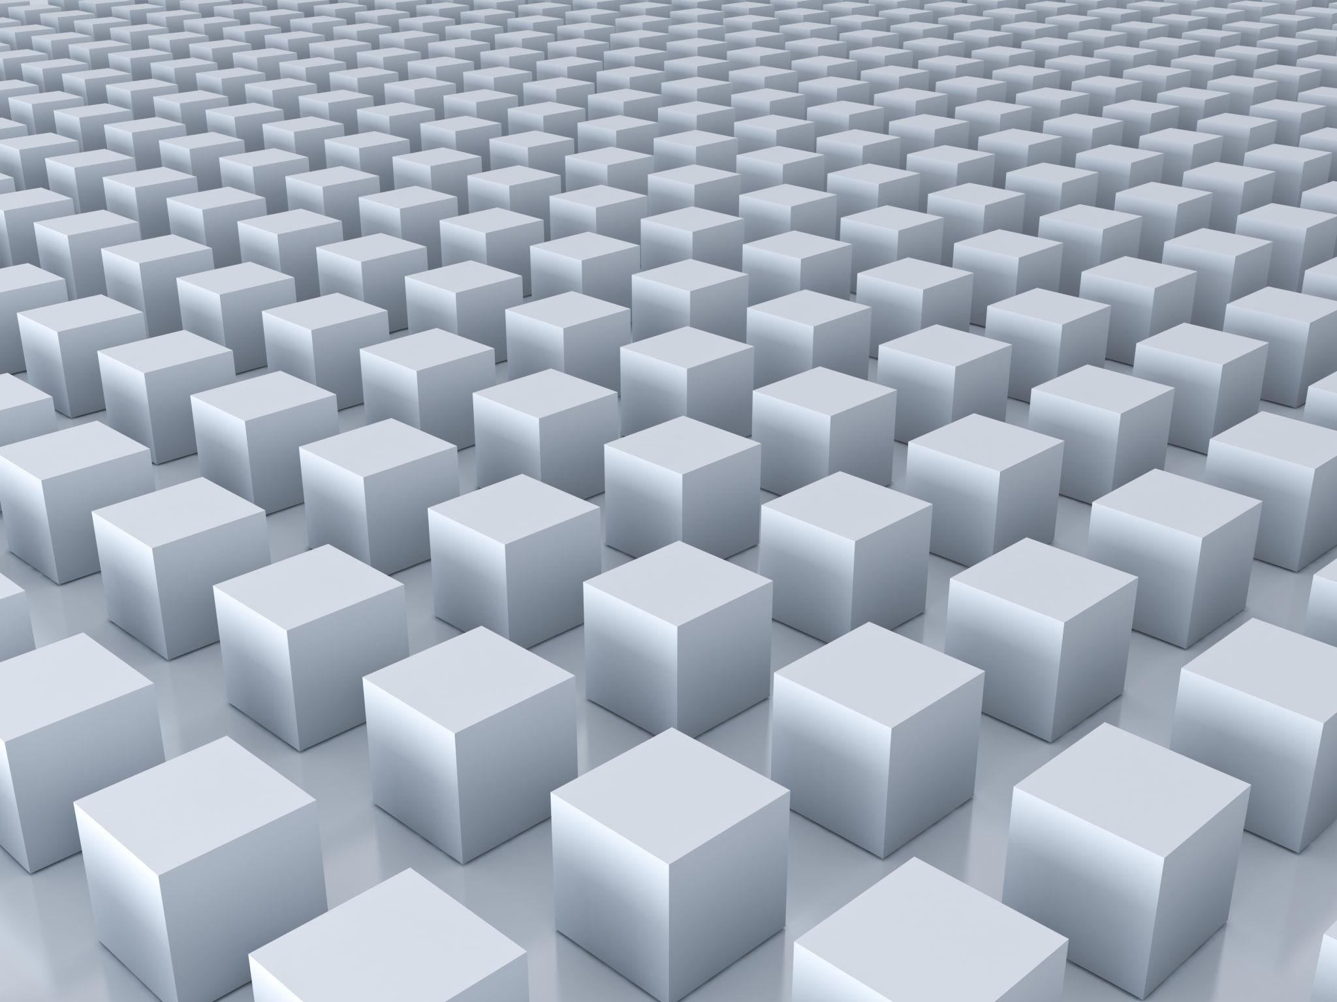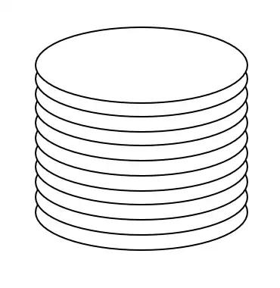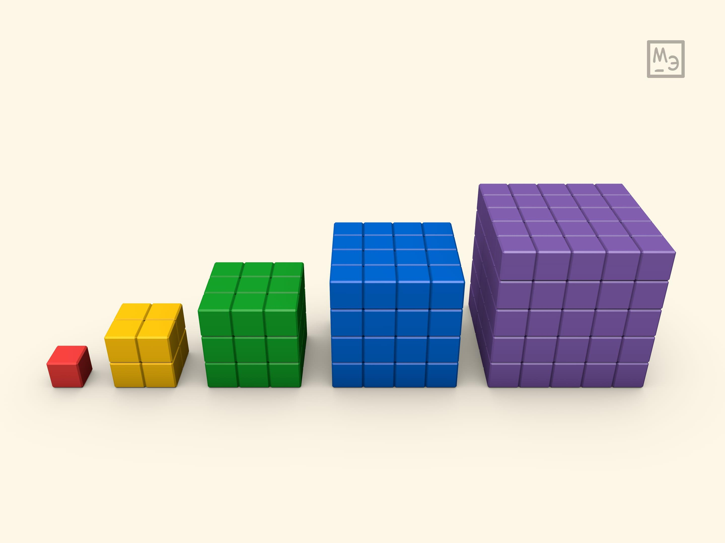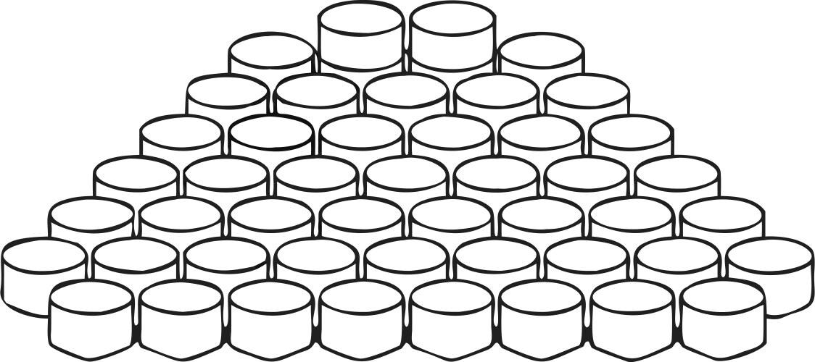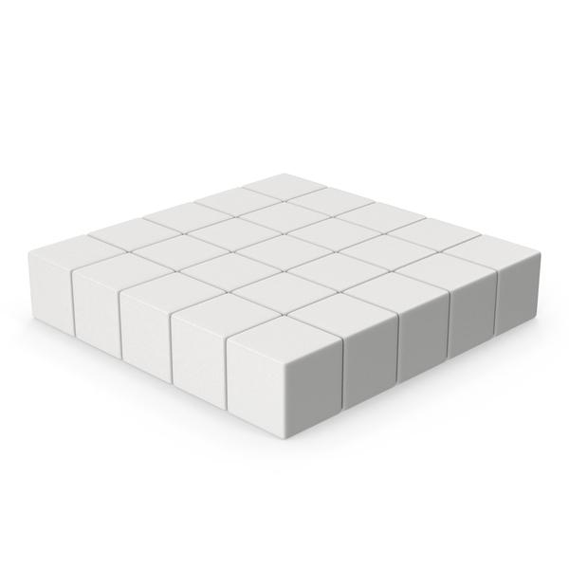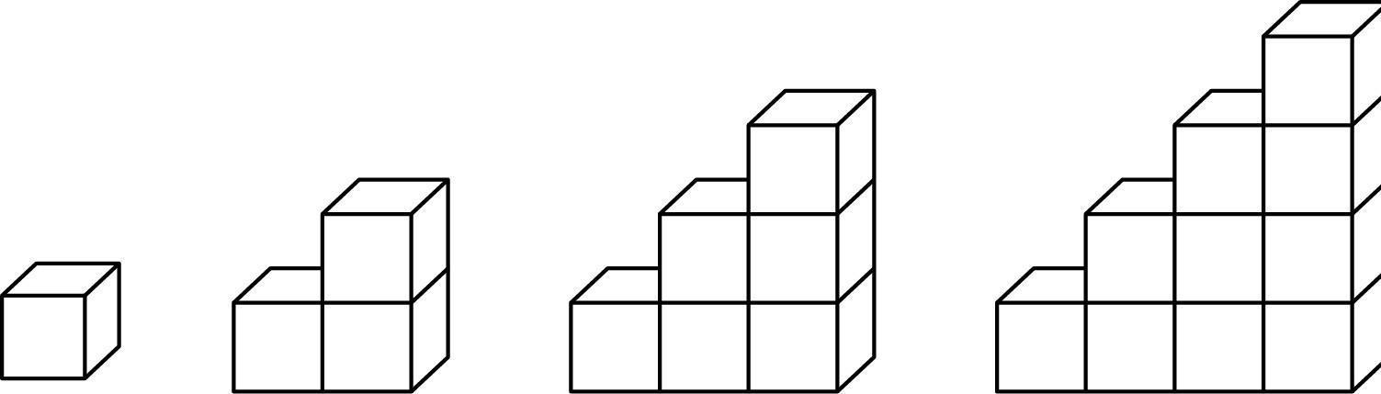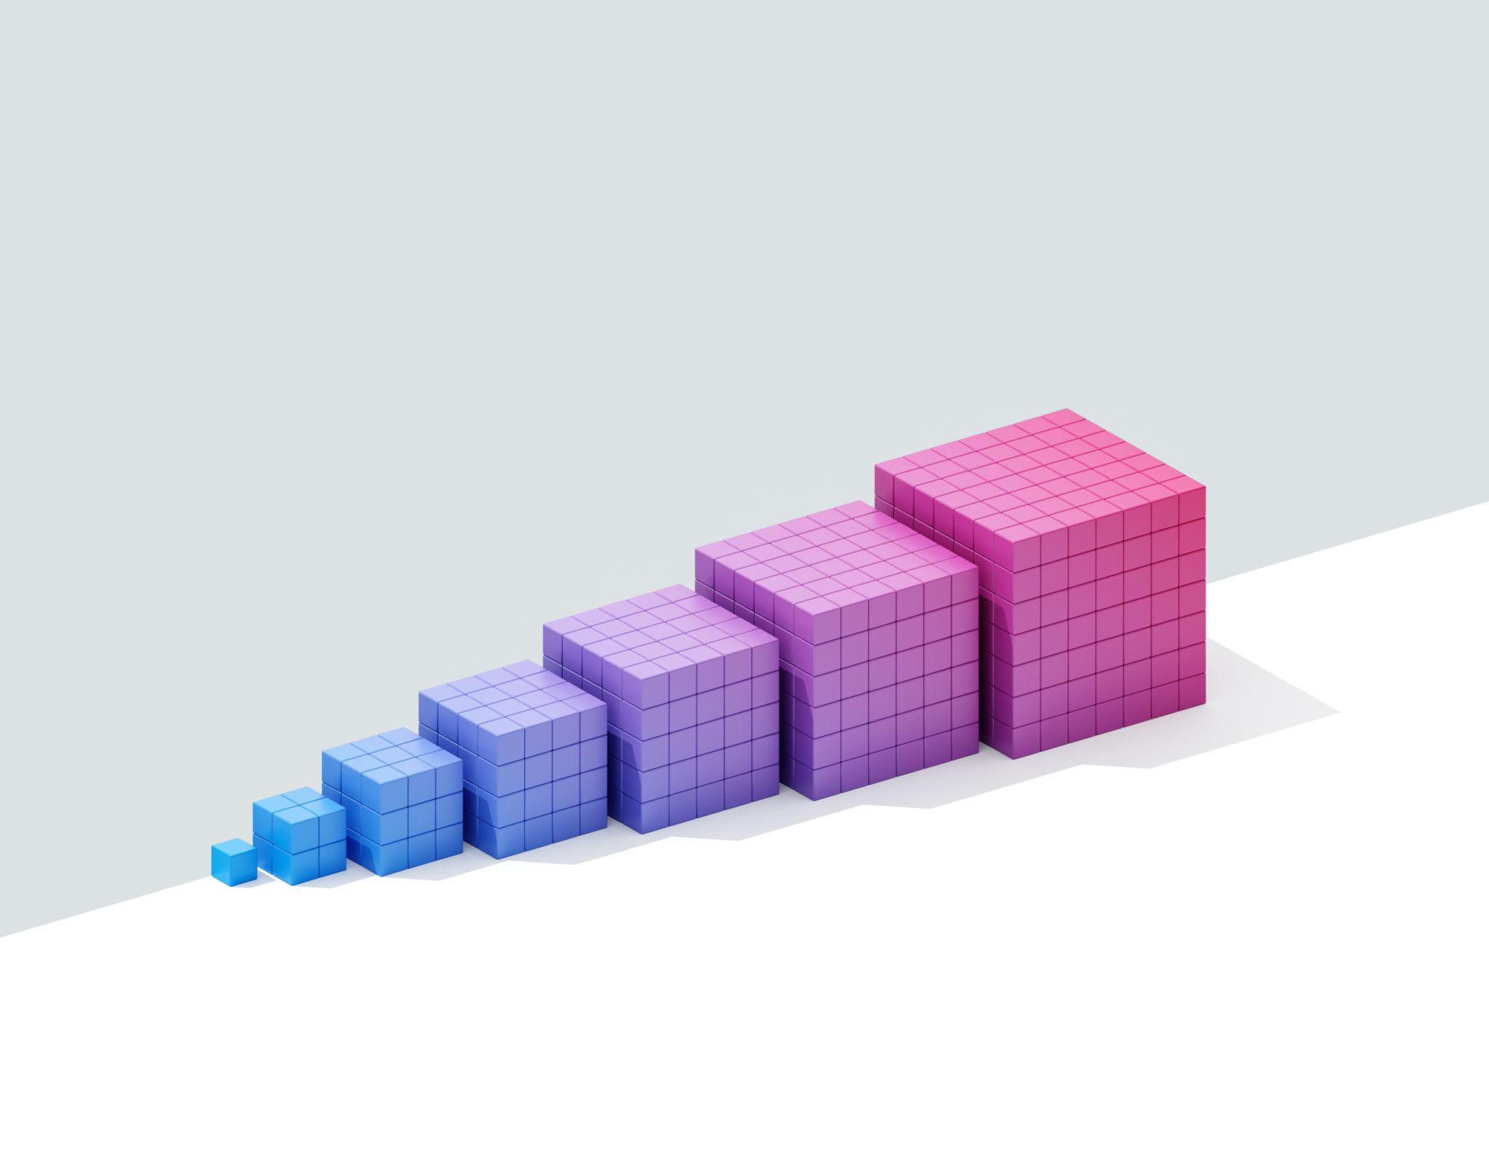
These examples demonstrate uniform repetition through identical dimensions, regular arrangements, and consistent dimensional progression.

Main Classification
# Source: AI Source: Provided by: [Data Path: Persons Table -> ID Column: 1, Name_En Column: Motasem Essam] -> From: [ChatGPT] on [7/25/2026]
Uniform repeated components can be classified according to the geometric shape being repeated.

Uniform Repeated Cubes
# Source: AI Source: Provided by: [Data Path: Persons Table -> ID Column: 1, Name_En Column: Motasem Essam] -> From: [ChatGPT] on [7/25/2026]
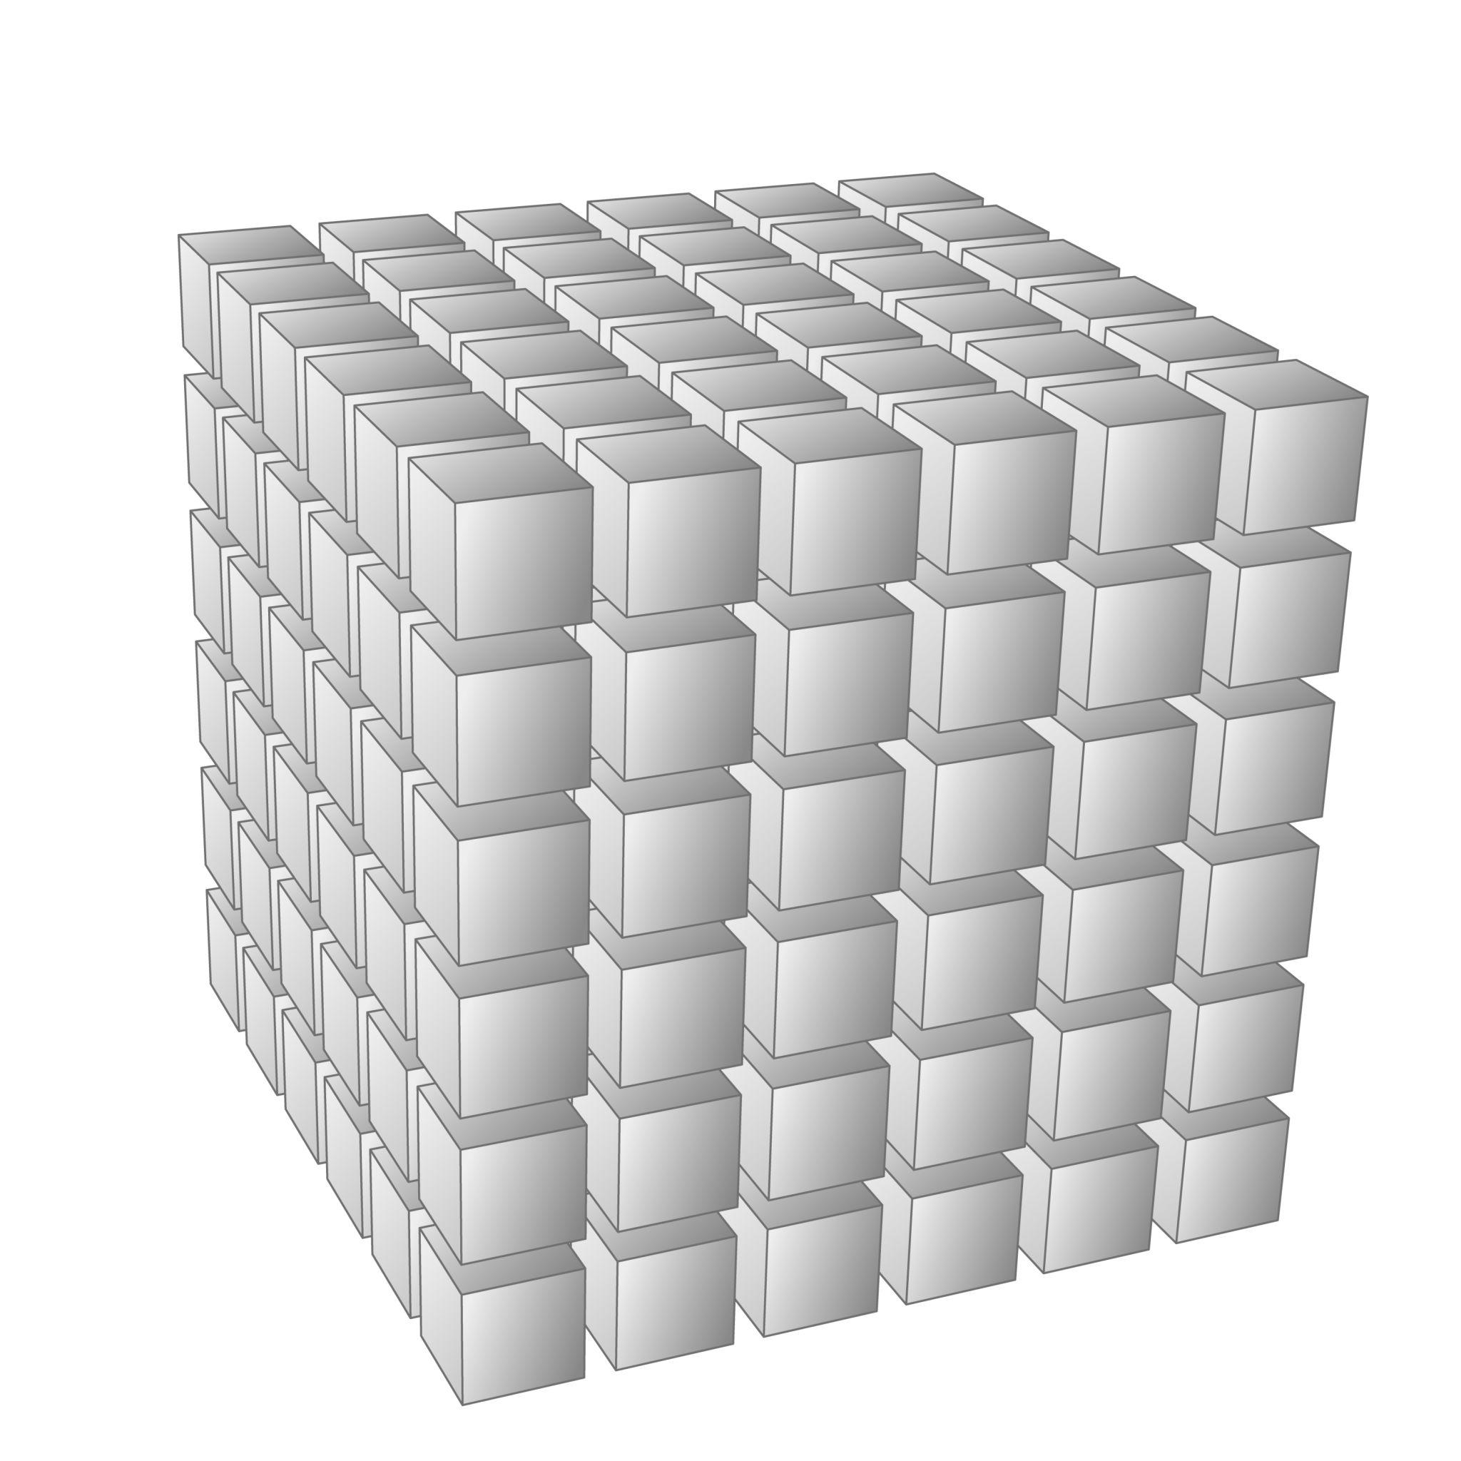
- Components are cubes.
- Repetition follows a consistent dimensional rule.
- Cubes may have identical side lengths or systematically changing side lengths.
For component $i$:
$$V_{i}=s_{i}^{3}$$
$${SA}_{i}=6s_{i}^{2}$$

Uniform Repeated Rectangular Prisms
# Source: AI Source: Provided by: [Data Path: Persons Table -> ID Column: 1, Name_En Column: Motasem Essam] -> From: [ChatGPT] on [7/25/2026]
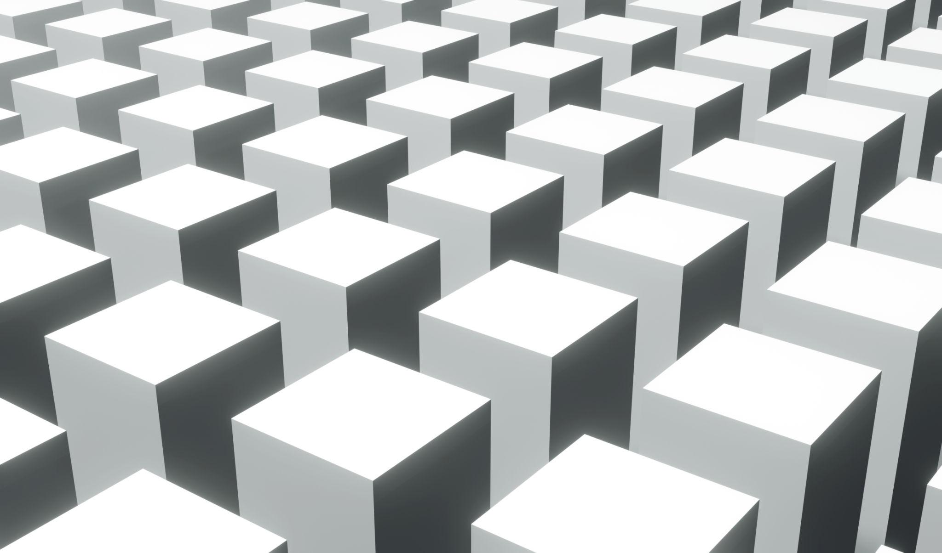
- Components are rectangular prisms.
- Their dimensions may be identical or follow a regular dimensional pattern.
- Corresponding dimensions may change according to fixed increments or ratios.
$$V_{i}=l_{i}$$

Uniform Repeated Cylinders
# Source: AI Source: Provided by: [Data Path: Persons Table -> ID Column: 1, Name_En Column: Motasem Essam] -> From: [ChatGPT] on [7/25/2026]
- Components are cylinders.
- Their radii and heights may be identical or follow consistent dimensional relationships.
- They may be stacked, aligned, or arranged in rows.
$$V_{i}=πr_{i}^{2}h_{i}$$

Uniform Repeated Cones
# Source: AI Source: Provided by: [Data Path: Persons Table -> ID Column: 1, Name_En Column: Motasem Essam] -> From: [ChatGPT] on [7/25/2026]
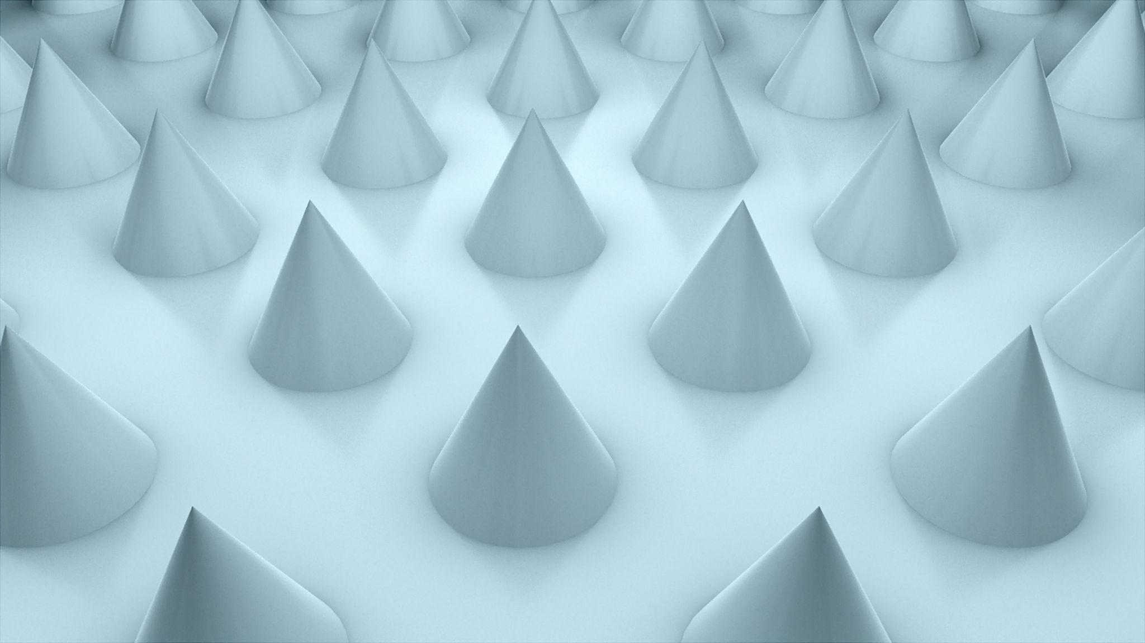
- Components are cones.
- Their base radii and heights may follow a consistent dimensional rule.
- They may have equal dimensions or systematically changing sizes.
$$V_{i}=\frac{1}{3}πr_{i}^{2}h_{i}$$

Uniform Repeated Pyramids
# Source: AI Source: Provided by: [Data Path: Persons Table -> ID Column: 1, Name_En Column: Motasem Essam] -> From: [ChatGPT] on [7/25/2026]
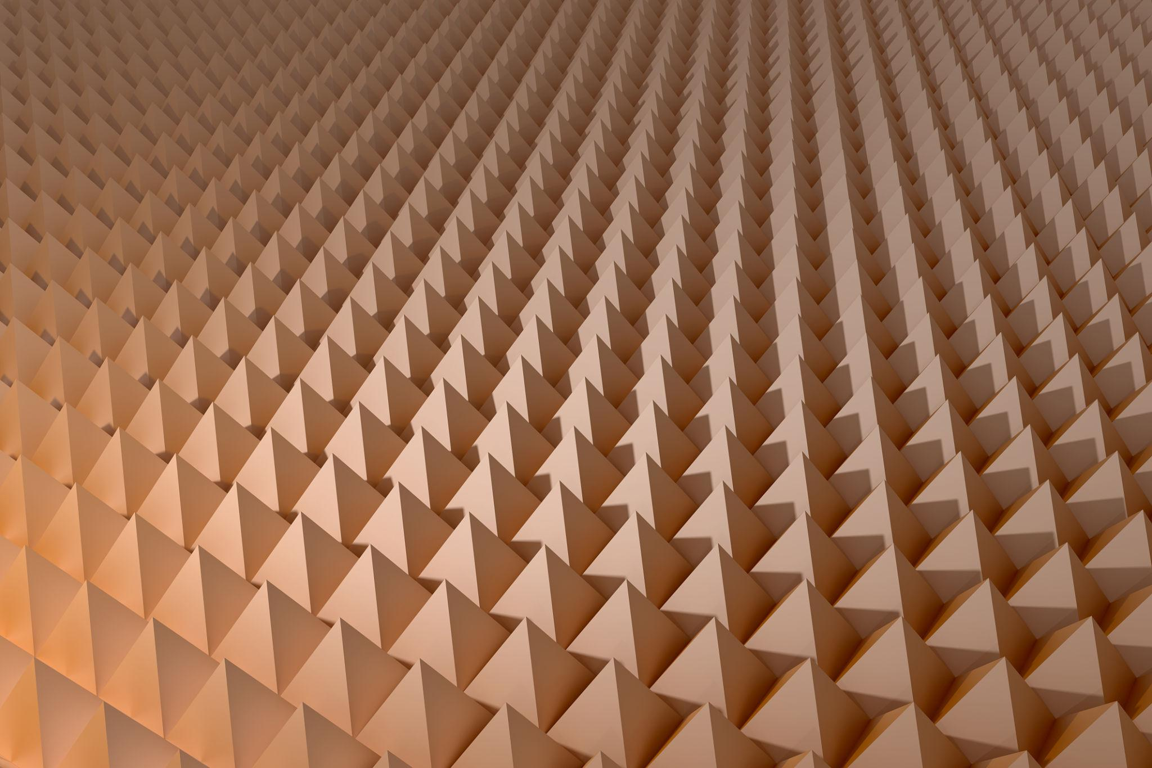
- Components are pyramids of the same geometric type.
- Their base dimensions and heights follow a consistent pattern.
- They may be arranged in layers or repeated spatial configurations.
$$V_{i}=\frac{1}{3}B_{i}$$

Uniform Repeated Spheres
# Source: AI Source: Provided by: [Data Path: Persons Table -> ID Column: 1, Name_En Column: Motasem Essam] -> From: [ChatGPT] on [7/25/2026]
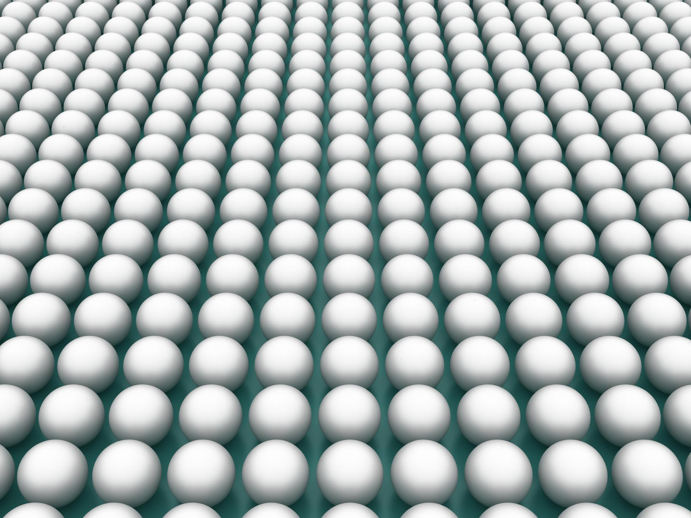
- Components are spheres.
- Their radii may be equal or follow a consistent dimensional progression.
- They may be arranged in rows, layers, or circular patterns.
$$V_{i}=\frac{4}{3}πr_{i}^{3}$$

Uniform Repeated Hemispheres
# Source: AI Source: Provided by: [Data Path: Persons Table -> ID Column: 1, Name_En Column: Motasem Essam] -> From: [ChatGPT] on [7/25/2026]
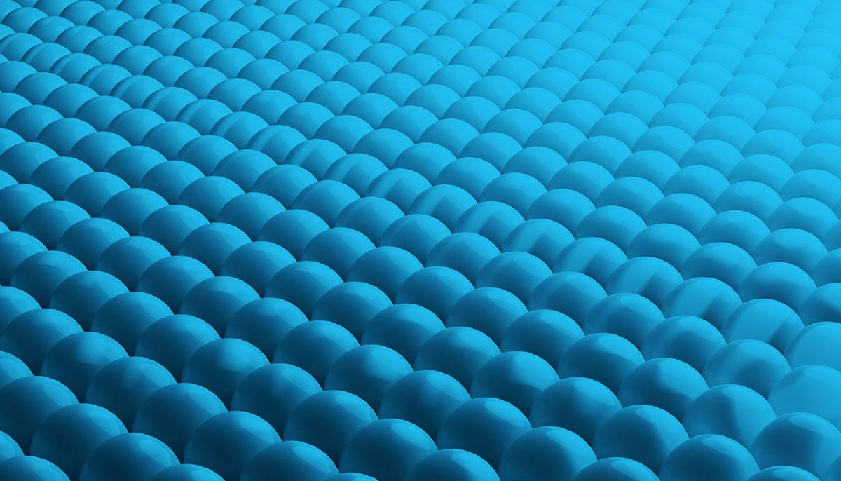
- Components are hemispheres.
- Their radii may be identical or follow a regular size relationship.
- They may be arranged through their flat bases or other contact regions.
$$V_{i}=\frac{2}{3}πr_{i}^{3}$$

Classification by Dimensional Repetition Pattern

Identical-Dimension Repetition
# Source: AI Source: Provided by: [Data Path: Persons Table -> ID Column: 1, Name_En Column: Motasem Essam] -> From: [ChatGPT] on [7/25/2026]
All repeated components have exactly the same dimensions.
Example:
$$s_{1}=s_{2}=s_{3}=s_{4}=3 cm$$
This is the most direct form of uniform repetition.

Arithmetic Dimensional Progression
# Source: AI Source: Provided by: [Data Path: Persons Table -> ID Column: 1, Name_En Column: Motasem Essam] -> From: [ChatGPT] on [7/25/2026]
Component dimensions increase or decrease by a constant difference.
Example:
$$s_{i}=2,4,6,8,10 cm$$
The common difference is:
$$d=s_{i+1}-s_{i}=2 cm$$
General formula:
$$\boxed{s_{i}=s_{1}+(i-1)d}$$

Geometric Dimensional Progression
# Source: AI Source: Provided by: [Data Path: Persons Table -> ID Column: 1, Name_En Column: Motasem Essam] -> From: [ChatGPT] on [7/25/2026]
Component dimensions change according to a constant multiplication factor.
Example:
$$s_{i}=2,4,8,16 cm$$
The common ratio is:
$$q=\frac{s_{i+1}}{s_{i}}=2$$
General formula:
$$\boxed{s_{i}=s_{1}q^{i-1}}$$

Alternating Dimensional Repetition
# Source: AI Source: Provided by: [Data Path: Persons Table -> ID Column: 1, Name_En Column: Motasem Essam] -> From: [ChatGPT] on [7/25/2026]
Component dimensions alternate according to a repeating sequence.
Example:
$$s_{i}=2,4,2,4,2,4 cm$$

Periodic Dimensional Repetition
# Source: AI Source: Provided by: [Data Path: Persons Table -> ID Column: 1, Name_En Column: Motasem Essam] -> From: [ChatGPT] on [7/25/2026]
A dimensional sequence repeats after a fixed number of components.
Example:
$$s_{i}=2,3,4,2,3,4,2,3,4 cm$$
The repeating period contains three dimensional values.

Uniform Proportional Repetition
# Source: AI Source: Provided by: [Data Path: Persons Table -> ID Column: 1, Name_En Column: Motasem Essam] -> From: [ChatGPT] on [7/25/2026]
Components have different dimensions but maintain the same proportional relationships.
For example, rectangular prisms with dimensions:
$$(2,3,4), (4,6,8), (6,9,12)$$
All dimensions follow a common proportional relationship.

Classification by Dimensional Consistency
# Source: AI Source: Provided by: [Data Path: Persons Table -> ID Column: 1, Name_En Column: Motasem Essam] -> From: [ChatGPT] on [7/25/2026]
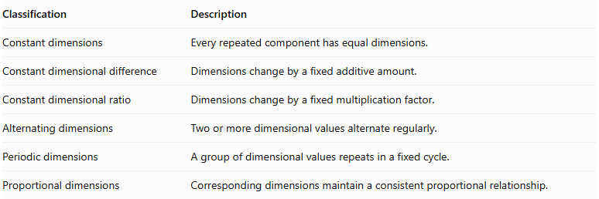
Classification | Description
Constant dimensions | Every repeated component has equal dimensions.
Constant dimensional difference | Dimensions change by a fixed additive amount.
Constant dimensional ratio | Dimensions change by a fixed multiplication factor.
Alternating dimensions | Two or more dimensional values alternate regularly.
Periodic dimensions | A group of dimensional values repeats in a fixed cycle.
Proportional dimensions | Corresponding dimensions maintain a consistent proportional relationship.

Classification by Repetition Arrangement
# Source: AI Source: Provided by: [Data Path: Persons Table -> ID Column: 1, Name_En Column: Motasem Essam] -> From: [ChatGPT] on [7/25/2026]
Uniform repeated components can be organized into several spatial configurations.
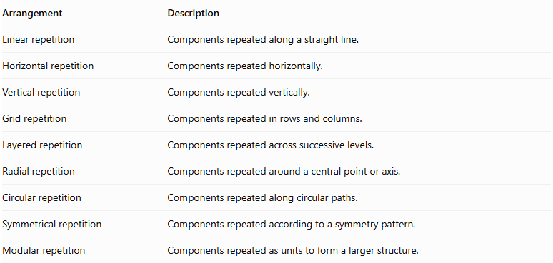
Arrangement | Description
Linear repetition | Components repeated along a straight line.
Horizontal repetition | Components repeated horizontally.
Vertical repetition | Components repeated vertically.
Grid repetition | Components repeated in rows and columns.
Layered repetition | Components repeated across successive levels.
Radial repetition | Components repeated around a central point or axis.
Circular repetition | Components repeated along circular paths.
Symmetrical repetition | Components repeated according to a symmetry pattern.
Modular repetition | Components repeated as units to form a larger structure.

Mathematical Properties and Formulas

Total Number of Components
# Source: AI Source: Provided by: [Data Path: Persons Table -> ID Column: 1, Name_En Column: Motasem Essam] -> From: [ChatGPT] on [7/25/2026]
For a repeated arrangement:
$$\boxed{N=n}$$
For a regular three-dimensional grid:
$$\boxed{N=R×C×L}$$
Where:
- $R$ = Number of rows.
- $C$ = Number of columns.
- $L$ = Number of layers.

Total Volume
# Source: AI Source: Provided by: [Data Path: Persons Table -> ID Column: 1, Name_En Column: Motasem Essam] -> From: [ChatGPT] on [7/25/2026]
For non-overlapping components:
$$\boxed{V_{total}=\sum_{i=1}^{n}{V_{i}}}$$
For identical components:
$$\boxed{V_{total}={nV}_{c}}$$
For cubes with an arithmetic side-length progression:
$$V_{total}=\sum_{i=1}^{n}{[}s_{1}+(i-1)d]^{3}$$
For cubes with a geometric side-length progression:
$$V_{total}=\sum_{i=1}^{n}{(}s_{1}q^{i-1})^{3}$$

Total External Surface Area
# Source: AI Source: Provided by: [Data Path: Persons Table -> ID Column: 1, Name_En Column: Motasem Essam] -> From: [ChatGPT] on [7/25/2026]
For complete matching planar joining faces:
$$\boxed{{SA}_{total}=\sum_{i=1}^{n}{{SA}_{i}}-2\sum_{j=1}^{k}{A_{j}}}$$
The formula subtracts the hidden joining regions from the sum of individual surface areas.
For partial contact or curved intersections, calculate the actual exposed surface areas instead.

Arithmetic Progression of Dimensions
# Source: AI Source: Provided by: [Data Path: Persons Table -> ID Column: 1, Name_En Column: Motasem Essam] -> From: [ChatGPT] on [7/25/2026]
The $n$-th component dimension is:
$$\boxed{a_{n}=a_{1}+(n-1)d}$$
The sum of component dimensions is:
$$\boxed{S_{n}=\frac{n}{2}[2a_{1}+(n-1)d]}$$

Geometric Progression of Dimensions
# Source: AI Source: Provided by: [Data Path: Persons Table -> ID Column: 1, Name_En Column: Motasem Essam] -> From: [ChatGPT] on [7/25/2026]
The $n$-th component dimension is:
$$\boxed{a_{n}=a_{1}q^{n-1}}$$
For $q≠1$, the sum is:
$$\boxed{S_{n}=a_{1}\frac{q^{n}-1}{q-1}}$$
These progression formulas describe linear dimensions. They should not be confused with total volume or surface area, which require applying the appropriate geometric formulas to each component.

Worked Examples

Example 1: Cubes with Uniformly Increasing Dimensions
# Source: AI Source: Provided by: [Data Path: Persons Table -> ID Column: 1, Name_En Column: Motasem Essam] -> From: [ChatGPT] on [7/25/2026]
Given:
Four cubes are joined consecutively in a row.
Their side lengths follow an arithmetic progression:
$$s_{1}=2 cm, d=2 cm$$
Therefore, their side lengths are:
$$2, 4, 6, 8 cm$$
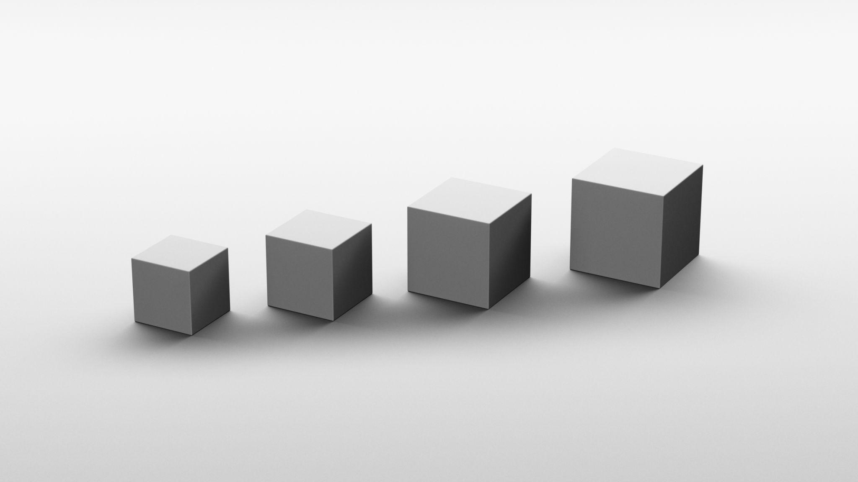
Step 1: Calculate the volume of each cube.
$$V_{1}=2^{3}=8$$
$$V_{2}=4^{3}=64$$
$$V_{3}=6^{3}=216$$
$$V_{4}=8^{3}=512$$
Step 2: Calculate the total volume.
$$V_{total}=8+64+216+512$$
$$\boxed{V_{total}=800{ cm}^{3}}$$
Step 3: Calculate the overall length.
Assuming the cubes are positioned consecutively along the same straight direction without overlap:
$$L=2+4+6+8$$
$$\boxed{L=20 cm}$$
Step 4: Calculate the total external surface area.
Assume each successive cube is joined to the next through a complete square region matching the smaller cube's face.
Individual surface areas:
$${SA}_{1}=24, {SA}_{2}=96$$
$${SA}_{3}=216, {SA}_{4}=384$$
Shared contact areas:
$$A_{1}=2^{2}=4$$
$$A_{2}=4^{2}=16$$
$$A_{3}=6^{2}=36$$
Therefore:
$${SA}_{total}=24+96+216+384-2(4+16+36)$$
$$=720-112$$
$$\boxed{{SA}_{total}=608{ cm}^{2}}$$

Example 2: Cylinders with Uniformly Decreasing Dimensions
# Source: AI Source: Provided by: [Data Path: Persons Table -> ID Column: 1, Name_En Column: Motasem Essam] -> From: [ChatGPT] on [7/25/2026]
Given:
Three coaxial cylinders are stacked vertically.
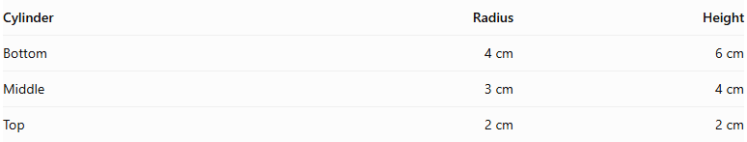
Cylinder | Radius | Height
Bottom | 4 cm | 6 cm
Middle | 3 cm | 4 cm
Top | 2 cm | 2 cm
The radii decrease by 1 cm, and the heights decrease by 2 cm.
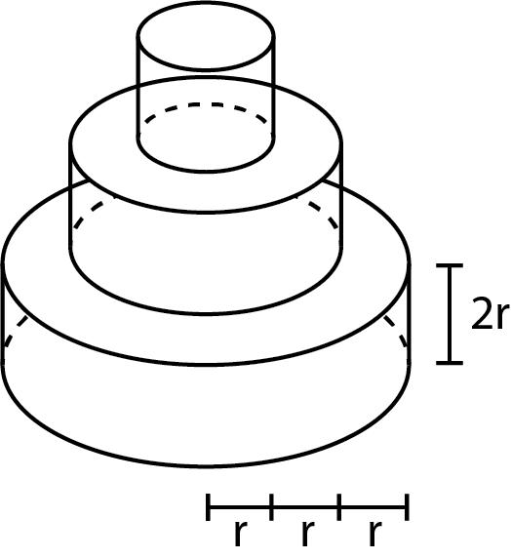
Step 1: Calculate the volume of each cylinder.
Bottom:
$$V_{1}=π(4)^{2}(6)=96π$$
Middle:
$$V_{2}=π(3)^{2}(4)=36π$$
Top:
$$V_{3}=π(2)^{2}(2)=8π$$
Step 2: Calculate the total volume.
$$V_{total}=96π+36π+8π$$
$$\boxed{V_{total}=140π≈439.82{ cm}^{3}}$$
Step 3: Calculate the total external surface area.
Individual surface areas:
$${SA}_{1}=2π(4)(4+6)=80π$$
$${SA}_{2}=2π(3)(3+4)=42π$$
$${SA}_{3}=2π(2)(2+2)=16π$$
The joining regions have radii 3 cm and 2 cm:
$$A_{1}=9π, A_{2}=4π$$
Therefore:
$${SA}_{total}=80π+42π+16π-2(9π+4π)$$
$$=138π-26π$$
$$\boxed{{SA}_{total}=112π≈351.86{ cm}^{2}}$$
Step 4: Calculate the overall height.
$$H=6+4+2$$
$$\boxed{H=12 cm}$$

Important Characteristics
# Source: AI Source: Provided by: [Data Path: Persons Table -> ID Column: 1, Name_En Column: Motasem Essam] -> From: [ChatGPT] on [7/25/2026]
- Consistent repetition: Components follow a defined dimensional repetition rule.
- Same geometric category: Repeated components belong to the same geometric shape category.
- Dimensional regularity: Dimensions may remain constant or change systematically.
- Predictable progression: Arithmetic, geometric, alternating, and periodic patterns can be described mathematically.
- Flexible arrangement: Components may be organized in different spatial configurations.
- Variable component sizes: Not every component must have identical dimensions.
- Variable total surface area: External surface area depends on the joining regions and arrangement.
- Expandable structure: Additional components can be introduced while maintaining the same repetition rule.

Comparison with Related Classifications
# Source: AI Source: Provided by: [Data Path: Persons Table -> ID Column: 1, Name_En Column: Motasem Essam] -> From: [ChatGPT] on [7/25/2026]
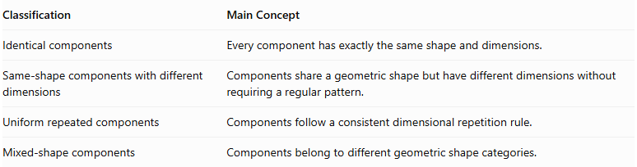
Classification | Main Concept
Identical components | Every component has exactly the same shape and dimensions.
Same-shape components with different dimensions | Components share a geometric shape but have different dimensions without requiring a regular pattern.
Uniform repeated components | Components follow a consistent dimensional repetition rule.
Mixed-shape components | Components belong to different geometric shape categories.
Important distinction:
- Identical components focus on equal dimensions.
- Same-shape components with different dimensions focus on size differences.
- Uniform repeated components focus on consistency in the dimensional repetition pattern.
These classifications can overlap. For example, four identical cubes also form a uniform repeated arrangement.

Applications
# Source: AI Source: Provided by: [Data Path: Persons Table -> ID Column: 1, Name_En Column: Motasem Essam] -> From: [ChatGPT] on [7/25/2026]
- Architecture: Repeated building blocks with consistent dimensional patterns.
- Construction: Regularly sized structural components and progressively stepped structures.
- Manufacturing: Repeated parts produced according to fixed dimensional specifications.
- Mechanical engineering: Stepped cylindrical structures and repeated components with predictable size changes.
- Packaging: Regular arrangements of containers with consistent size progressions.
- Mathematics: Geometric sequences, arithmetic progressions, spatial patterns, and composite-solid calculations.

Key Points
# Source: AI Source: Provided by: [Data Path: Persons Table -> ID Column: 1, Name_En Column: Motasem Essam] -> From: [ChatGPT] on [7/25/2026]
- Uniform repeated components follow a consistent dimensional repetition rule.
- Components may have identical or systematically different dimensions.
- Dimensional patterns may be constant, arithmetic, geometric, alternating, or periodic.
- The total volume is the sum of individual component volumes when there is no overlap.
- External surface area depends on the actual exposed and hidden surfaces.
- Uniform repetition can occur in linear, vertical, horizontal, grid, layered, radial, and circular arrangements.
- Uniform repetition is broader than identical-component repetition.

Conclusion
# Source: AI Source: Provided by: [Data Path: Persons Table -> ID Column: 1, Name_En Column: Motasem Essam] -> From: [ChatGPT] on [7/25/2026]
Uniform repeated components are used to construct composite solids through a consistent pattern of geometric repetition. Their dimensions may remain identical or change according to a predictable mathematical relationship. This classification connects composite-solid geometry with arithmetic progressions, geometric progressions, and repeated modular structures, making it useful for studying both regular and progressively changing three-dimensional configurations.

